SPANISH Fluency Revision Booklet for year 11 Revision

Weeks between Easter and Speaking Exams: Exam-focused Weeks

This Booklet can be used in conjunction with anything else the department is currently using, such as GCSE revision guides.

AQA specified vocabulary per topic can be found [here for Spanish](https://unitedlearning-my.sharepoint.com/:x:/g/personal/mariu_hurriaga_unitedlearning_org_uk/Ed0JAEgzqn1KruByvrD6L6kB7KBnq5dx_uph16DioNeznw?e=ryg0dN) and in the Fluency-Revision booklets for the Revisiting weeks.

Weeks between Easter and Speaking exams

**Writing practice in preparation for both the Writing and Speaking exams:**

* **to be done in lessons, with minimal or preferably no support and teacher supervision (circulate with purpose)**
* **divided into clear chunks of time, such as 5 minutes to work out content and note down key verbs to use in the right time frame, key WOW phrases**
* **always including improvement time at the end: different colour pen, teacher guiding pupils to correct common mistakes and to ensure the piece would impress the examiner**

**Independent Speaking suggestions and links to further resources can be found at the end of this booklet.**

**WEEK 1**

**Common to both tiers:** 20-25 words answering these bullet points (one per topic)

Theme 1

* ¿Te llevas bien con tu familia ? ¿Cómo son tus padres/hermanos ?
* ¿Cuál es tu opinión sobre las redes sociales ?
* ¿Qué hiciste el fin de semana pasado con tus amigos ?
* ¿Qué festival de un país de habla hispana te gustaría visitar y por qué ?

Theme 2

* En el futuro, ¿quieres vivir en una ciudad o prefieres vivir en el campo ? ¿por qué ?
* ¿Llevas una vida sana?
* En tu opinión, ¿cuál es el problema medioambiental más grave ?
* Escribe sobre tus peores vacaciones

Theme 3

* En tu opinión, ¿qué asignaturas deberían ser obligatorias y por qué ?
* ¿Qué cambiarías de tu instituto y por qué ?
* ¿Qué planes tienes para el futuro en relación a tus estudios ?
* Para ti, ¿qué es lo más importante al elegir un trabajo ?

**Foundation Tier:** A) photo description and B) 40-50 words tasks.

Photo 1



¿Qué hay en la foto? Escribe cuatro frases en español.

________________________________________________________________________________________________________________________________________________________________________________________________________________________________________________________________________________________________________________________________________

Photo 2

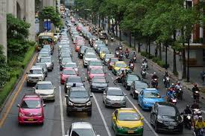

¿Qué hay en la foto? Escribe cuatro frases en español.

________________________________________________________________________________________________________________________________________________________________________________________________________________________________________________________________________________________________________________________________________

Photo 3



¿Qué hay en la foto? Escribe cuatro frases en español.

________________________________________________________________________________________________________________________________________________________________________________________________________________________________________________________________________________________________________________________________________

B. Write approximately 10-15 words for each of these topics (tick them as you complete them). Focus on accuracy. You don’t need to add different time frames but should try to connect sentences and add opinions.

|  |  |
| --- | --- |
| * Familia * Redes sociales * Tiempo libre * Comida | * Amigos * Centro comercial * Cine * Instituto |

________________________________________________________________________________________________________________________________________________________________________________________________________________________________________________________________________________________________________________________________________________________________________________________________________________________________________________________________________________________________________________________________________________________________________________________________________________________________________________________________________________

**Higher Tier:** Answer these questions writing approximately 150 words and focus on adding variety and complexity, connecting sentences and ideas. Check for accuracy:

* ¿Qué riesgos de las nuevas tecnologías te preocupan más y cómo crees que van a evolucionar en el futuro ?
* ¿Crees que estamos obsesionados con el culto al cuerpo ? ¿Cómo ha cambiado nuestro concepto de vida sana en los últimos años ?
* Si fueras director/a de un instituto, ¿qué reglas impondrías y qué cambiarías ?

**WEEK 2**

**Common to both tiers:** 20-25 words answering these bullet points (one per topic)

Theme 1

* Para ti, ¿qué es más importante la familia o los amigos?
* ¿Qué riesgos tienen las nuevas tecnologías ?
* ¿Cómo celebraste tu último cumpleaños?
* ¿Quieres visitar un país de habla hispana en el futuro?

Theme 2

* ¿Qué ventajas tiene vivir en una gran ciudad ?
* ¿Qué hacen los miembros de tu familia para mantenerse en forma?
* ¿Cómo has ayudado al medioambiente recientemente?
* ¿Cómo serían tus vacaciones ideales?

Theme 3

* ¿Qué asignaturas prefieres y por qué ?
* ¿Qué opinas del uniforme escolar ?
* ¿Qué vas a hacer el año que viene?
* Describe un día fantástico que tuviste en el colegio

**Foundation Tier:** A) photo description and B) 40-50 words tasks.

Photo 1



¿Qué hay en la foto? Escribe cuatro frases en español.

________________________________________________________________________________________________________________________________________________________________________________________________________________________________________________________________________________________________________________________________________

Photo 2

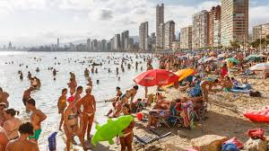

¿Qué hay en la foto? Escribe cuatro frases en español.

________________________________________________________________________________________________________________________________________________________________________________________________________________________________________________________________________________________________________________________________________

Photo 3



¿Qué hay en la foto? Escribe cuatro frases en español.

________________________________________________________________________________________________________________________________________________________________________________________________________________________________________________________________________________________________________________________________________

B. Write approximately 10-15 words for each of these topics (tick them as you complete them). Focus on accuracy. You don’t need to add different time frames but should try to connect sentences and add opinions.

|  |  |
| --- | --- |
| * Deportes * Mi móvil * Asignaturas * Vida sana | * Reglas escolares * Ir de compras * Televisión y lectura * Trabajo |

________________________________________________________________________________________________________________________________________________________________________________________________________________________________________________________________________________________________________________________________________________________________________________________________________________________________________________________________________________________________________________________________________________________________________________________________________________________________________________________________________________

**Higher Tier:** Answer these questions writing approximately 150 words and focus on adding variety and complexity, connecting sentences and ideas. Check for accuracy:

* ¿Qué diferencias conoces entre la vida en España y la vida en Inglaterra ? ¿Te gustaría vivir y trabajar en el extranjero en el futuro?
* ¿Crees que el planeta tiene futuro o es demasiado tarde para proteger el medioambiente ? ¿Qué problema medioambiental te parece el más grave y por qué ?
* En tu opinión, ¿qué es lo más importante al elegir un trabajo o profesión? ¿Qué te gustaría hacer cuando seas mayor ?

**Independent Speaking practice in preparation for the Speaking exams**

It is recommended that you allocate sufficient time within your lessons for this independent practice that could follow the same pattern every week:

* **5/10 minutes preparation time**: writing if Role-play or Photocard, going over pre-written answers and memorising them if General Conversation
* Practice with a partner changing regularly and allowing for one-to-one with the teacher who could be one of the partner or “stations” (**speak-dating**)

**For the Role-plays and photocards** we recommend using past papers and sample papers and, if slightly adapted, the ones from the other board can also be used. Past papers can be found here:

[Link to AQA website for Languages](https://www.aqa.org.uk/subjects/languages/gcse)

[Link to Edexcel website for Languages](https://qualifications.pearson.com/en/qualifications/edexcel-gcses/modern-languages-2016.html)

There are some further resources to practise available in the hub, please [have a look](https://hub.unitedlearning.org.uk/teaching-learning/subjects/secondary/mfl/Pages/default.aspx) to save you time.

**For the General Conversation** we recommend concentrating on about 2-3 questions per topic and prioritise good delivery rather than quantity of questions. Good delivery refers to accurate and well pronounced answers who are detailed and include various time frames, connectives and WOW phrases.

We recommend you use the following booklets[1] or similar (feel free to adapt them to suit your classes). Pupils will use their pre-written answers to ensure they have very full responses to the questions in the final booklet.

It is good practice to get them to make one card per question with the question one side, and the answer on the other, to use in class and at home for revision purposes. Colour-coding might help some pupils. Please model to them how to learn the answers: highlight key words, identify key word in the question, try remembering sentence by sentence, coming up with a mental picture for tricky words/chunks/beginnings, etc.

You can direct pupils to [BBC Bitesize Spanish GCSE Revision Guides for AQA](https://www.bbc.co.uk/bitesize/examspecs/z4yyjhv) for further speaking practice (usually page 6 or 7 under each topic) and you could encourage them to record themselves for further improvement.

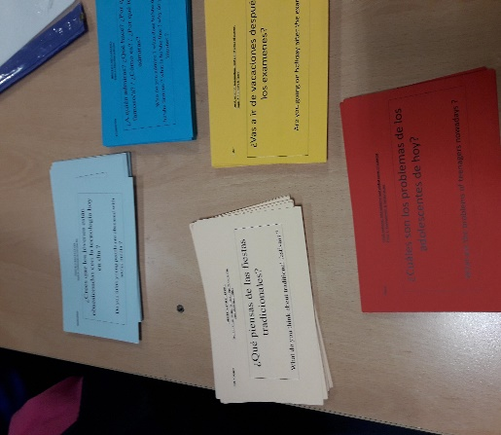

[General Conversation Spanish FT](https://unitedlearning-my.sharepoint.com/:w:/g/personal/mariu_hurriaga_unitedlearning_org_uk/EU8mkjS_mL9BtsjRBl2l1HgBwwQRrqpYU1aPqlDSPPtxyw?e=gBFsCV)

[General Conversation Spanish HT](https://unitedlearning-my.sharepoint.com/:w:/g/personal/mariu_hurriaga_unitedlearning_org_uk/Ea-MPPxDo21NsWPhUbLHIPUBGiGGBS0QCwnZHEN_Sk0RzA?e=BRtoy4)

An example of speaking cards[2]. As part of the revision process you might want to ask your pupils to write their own.

1. With our gratitude to Cecile Bernard, HoD at Goresbrook, from whose these were adapted.
2. Colour-coded cards used by Saima Baksh, HoD at Manchester Academy and her pupils. Thanks for sharing.